1. Design TM using simulator to accept the input string Palindrome bbabb

INPUT:

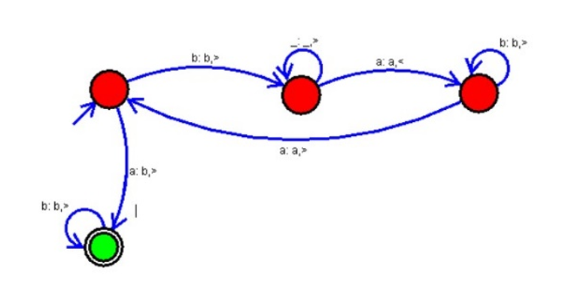

OUTPUT:

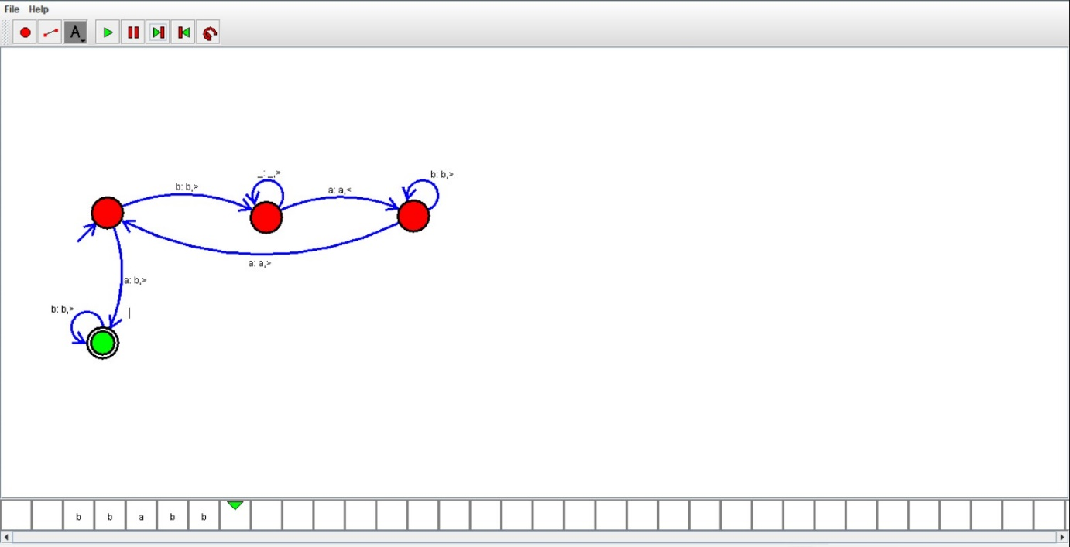

RESULT:

We designed TM using simulator to accept the input string Palindrome bbabb by using autosim